**Service Centre Management System**

**SRS for Service Centre Management Centre**

**Introduction:**

This document is meant to delineate the features of Service Centre Management System, so as to serve as a guide to the developers on one hand and a software validation document for the prospective client on the other.

Service Centre Management is a contract between service center and the customer. Service provider will exactly know about the customer needs and customer can choose different type of servicing, modification for his/her vehicle. Also the customer can specify the problems and service staff has to provide the exact solution. This application also give estimated time and price require for servicing.

**Scope:**

This application assist the service center to manage their customers and provide best service to them. And also allows the customer to get the service for their vehicle by providing their need

**Actors:**

Admin, Staff, Customer

**General Description:**

The real power of this project lies not in direct selling of products, but in the creation of tighter relationships with customers and delivering of a high level of service and support, which in turn improves organization sales and its goodwill. Also the system provides the transparency to the customer in the cost or bill that they are going to pay. As the customer himself/herself is going to choose the kind of product that is needed to be used in their vehicle, so that they will be fully aware of the pricing scenario.

**Functional Requirement:**

This section provides overview of the system. Various functional modules that can be implemented by the system will be:-

Login :- It allows all the actors to login/signup to their respective accounts.

Service :- Logged in customer would be required to choose the type of servicing. The logged in staff will able to acknowledge that he/she is working on particular vehicle. And that in case of admin he/she will be able to modify service module.

Bill Calculator :- Bill will be calculated depending on the choices made by the customer while choosing service type.

Payment :- In this system we are dealing with the mode of payment by cash. We will extend this to credit card, debit card, etc in the future

Logout :- Once the vehicle token number is generated and the customer pays the bill he/she shall be logged out.

**Non-Functional Requirements:**

Following Non-Functional Requirements will be there in the insurance to the internet:

(i) Secure access to consumer's confidential data.

(ii) 24X7 availability.

(iii) Better component design to get better performance at peak time.

(iv)Flexible service based architecture will be highly desirable for future extension. Non-Functional Requirements define system properties and constraints.

**Hardware Requirement:**

Processor : Intel core processor.

RAM : 512MB & more

Hard : 20 GB or more

**Software Requirement:**

Operating System : Windows 7 & above

Programming Language : Java 8

IDE : eclipse IDE

Database : my-SQL

**ER Diagram :-**

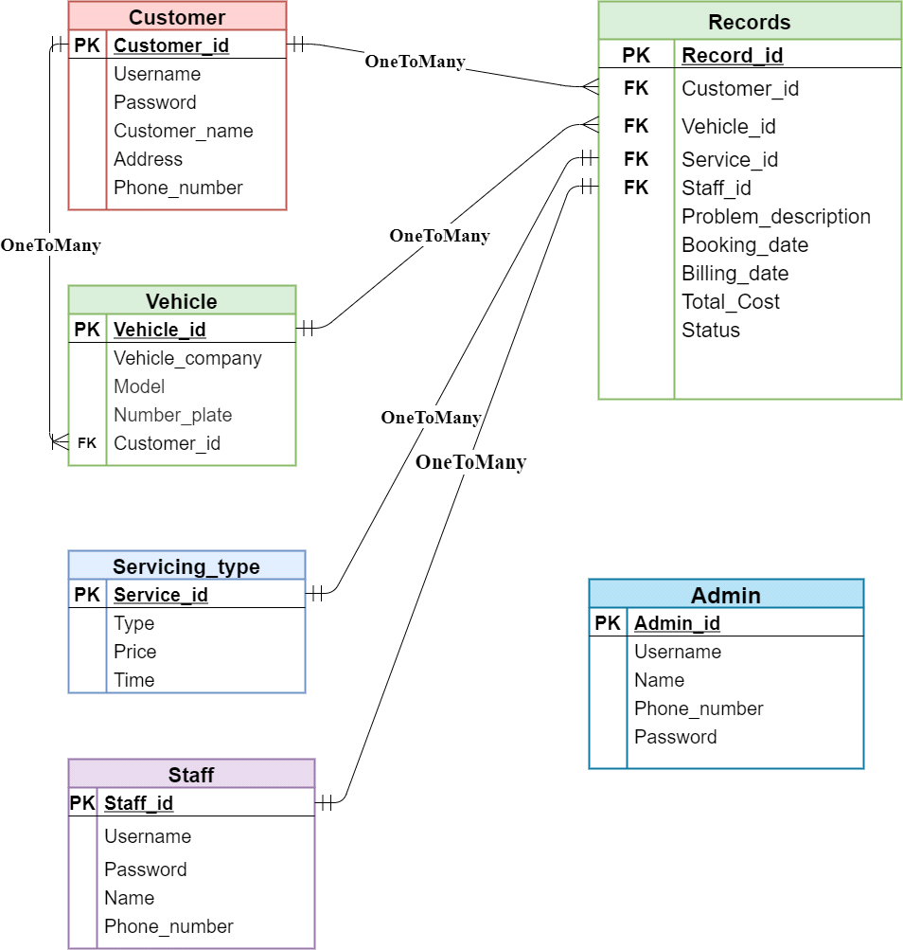

**Use Case Diagram :-**

